README for Grazioso Salvare Austin Animal Shelter Interactive Dashboard
Project Description
This project is an interactive dashboard that allows the user to search, sort, and filter data about animals in the Austin Animal Shelter database. Animals are selectable, sortable, and filterable. Animals can be filtered out by types of dogs suitable for water, mountain/wilderness, and disaster/individual rescue as well as filtered individual values in the dashboard like names, ages, animal types, and other columns. It features a pie chart that shows data of animals in the database and dynamically changes based on filter options. It features a map to show where the animal was found along with tooltips to show the dog type and name on the pin when hovering over or clicking on it. The Grazioso Salvare logo is an interactive hyperlink that takes you to the url www.snhu.edu. The dashboard limits animals displayed on the dashboard to 10 results at a time with pagination and limits to the animals shown in the pie chart to 10.

Motivation
The motivation of this project was to show understanding and proper execution of CRUD operations between python and MongoDB, and create an interactive dashboard allowing users to read, filter, sort, and visualize information about animals in the Austin Animal Shelter Database.
Installation
To get this project running, follow these steps.
- Open Codio module.
- Import Austin Animal Control CSV file into MongoDB and name the database aac.
- Use Admin database to create user credentials with read/write permissions in the database.
- Ensure aac database with user credentials are imported.
- Run MongoDB in your virtual environment.
- Open Jupyter Notebook in Codio.
- Import CRUD_Python_Module.py and ProjectTwoDashboard.ipynb
- Run the ProjectTwoDashboard.

Requirements
- Python 3
- MongoDB
- PyMongo
- Dash
- Dash Leaflet
- Pandas

PyMongo was chosen to provide a direct interface between Python and MongoDB. CRUD operations are supported natively and integrate easily with Python. Dash was used to create the interactive visualization of the data. Dash Leaflet is used to display map data of individual animals in the database. Pandas was used to create the pie chart based on data info.

Usage
The CRUD module can create, read, update and delete information in the Austin Animal Center database though projectTwoDashboard only uses it to read data.

The ProjectTwoDashboard reads data from the database and visualizes it in a dashboard showing a pie chart of animals and a map showing where the animal was found. It also can filter animals suitable for specific rescue training as well as filtering by column value. Every column is sortable and features pagination to keep from displaying the thousands of animals on one page.

Code Examples and Screenshots

The CRUD module uses these methods for creating, reading, updating, and deleting in the database.
#This method creates new data to import into the database.
def create(self, data):
if data is not None:
self.database.animals.insert_one(data) # data should be dictionary
return True
else:
return False

#This method reads data from the database.
def read(self, query):
if query is not None:
data = self.database.animals.find(query)
return list(data)
else:
return[]

#This method updates data in the database
def update(self, query, updatedInfo):
if query is not None and updatedInfo is not None:
result = self.database.animals.update_many(query, {"$set": updatedInfo})
return result.modified_count
else:
return 0
#This method deletes data from the database
def delete(self, query):
if query is not None:
result = self.database.animals.delete_many(query)
return result.deleted_count
else:
return 0

The ProjectTwoDashboard creates a datatable by reading the database information using this method
#Datatable
html.Hr(),
dash_table.DataTable(
id='datatable-id',
columns=[
{"name": i, "id": i, "deletable": False, "selectable": True, "filter_options":{'case':'insensitive'}} for i in df.columns #added filter_options to eliminate case sensitivity when filtering.
],
data=df.to_dict('records'),

row_selectable="single",
selected_rows=[0],
#pagination
page_action="native",
page_current=0,
page_size=10, #limits results to 10 per page
#row sorting
sort_action="native",
sort_mode="multi", #added for sorting by multiple categories at once.
filter_action="native" #filters results by keyword in a column. Filtering caused index errors, had to solve for that in the callback.

),
html.Br(),
html.Hr(),

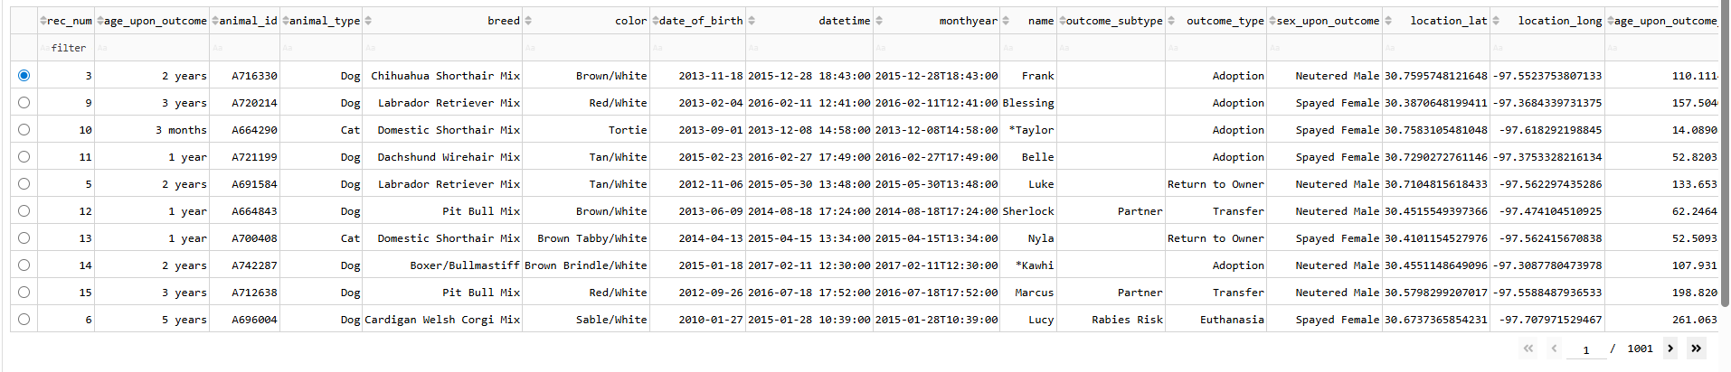
It creates a pie chart of the data with this method naming the pie chart based on radio button filters used and limiting to top 10 animals within any filtered or unfiltered dataset using this callback
@app.callback(
Output('graph-id', "children"),
[Input('datatable-id', "derived_virtual_data"),
Input('rescue-type-filter', 'value')])
def update_graphs(viewData, filter_type):

if viewData is None:
return[]

df = pd.DataFrame.from_dict(viewData)

if df.empty:
return[]

# Limit the pie chart to top 10 returned breeds to limit clutter.
top_breeds = df['breed'].value_counts().nlargest(10).index
df = df[df['breed'].isin(top_breeds)]

# Name the pie chart based on the rescue filter selected.
if filter_type == 'Water':
chart_title = 'Dogs Suitable For Water Rescue'
elif filter_type == 'Mountain':
chart_title = 'Dogs Suitable for Mountain and Wilderness Rescue'
elif filter_type == 'Disaster':
chart_title = 'Dogs Suitable for Disaster or Individual Tracking'
else:
chart_title = 'Shelter Animals (limited to top ten)'

# Return the pie chart
return [
dcc.Graph(
figure = px.pie(df, names='breed', title= chart_title)
)
]
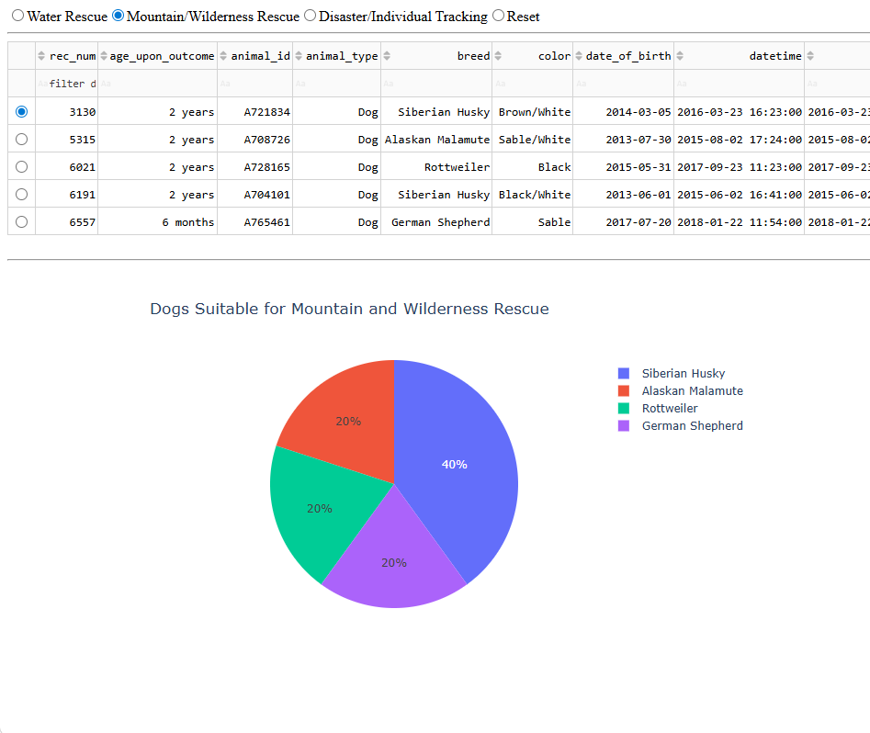

This callback creates a map with a marker of where a selected animal was found showing the animal breed and name when clicking or hovering over the pin
@app.callback(
Output('map-id', "children"),
[Input('datatable-id', "derived_virtual_data"),
Input('datatable-id', "derived_virtual_selected_rows")])
def update_map(viewData, index):
dff = pd.DataFrame.from_dict(viewData)

#if datatable is empty after filtering, "no data" is printed.
if dff.empty:
return[html.P("No Data")]

#uses first row if nothing is selected, otherwise ensure the selected index is within the index range, this solves the index error I was recieving when filtering.
row = 0 if not index else min(index[0], len(dff)-1)

return [
dl.Map(style={'width': '1000px', 'height': '500px'}, center=[dff.iloc[row,13],dff.iloc[row,14]], zoom=10, children=[
dl.TileLayer(id="base-layer-id"),
# Marker with tool tip and popup
# Column 13 and 14 define the grid-coordinates for the map
# Column 4 defines the breed for the animal, hover over the marker and it shows the animal breed
# Column 9 defines the name of the animal, click the marker and it shows the animal breed and name
dl.Marker(position=[dff.iloc[row,13],dff.iloc[row,14]], children=[
dl.Tooltip(dff.iloc[row,4]),
dl.Popup([
html.H1("Animal Name"),
html.P(dff.iloc[row,9])
])
])
])
]
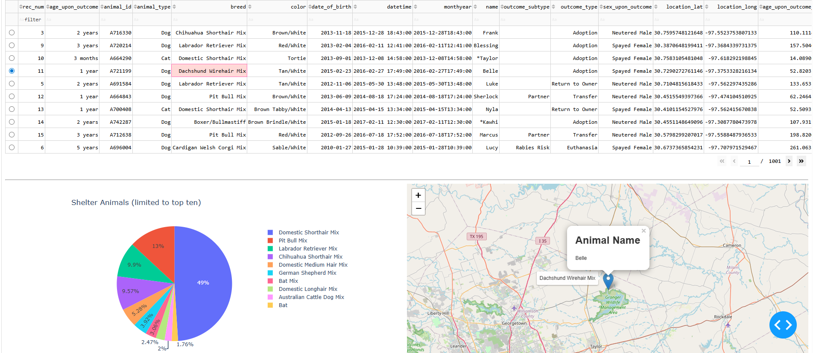

This method centers the pie chart and map on the page using a flexbox
#Setup map and pie chart side by side as well as center them for a cleaner look.
html.Div(className='row',
style={'display' : 'flex', 'justifyContent': 'center', 'alignItems': 'flex-start','width':'100%'},
children=[
html.Div(
id='graph-id',
style={'display': 'flex', 'justifyContent' : 'center', 'width': '50%'},

),
html.Div(
id='map-id',
style={'display': 'flex', 'justifyContent' : 'center', 'width': '50%'}
)
])
]) 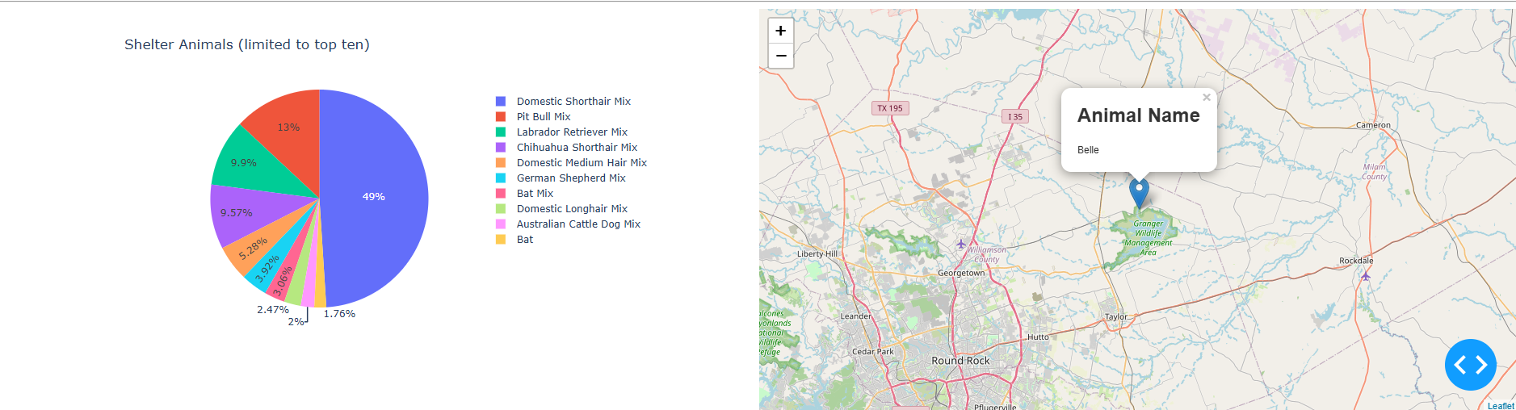

Future Improvements
Sorting and filtering functions could be upgraded in the future to feature things like multiple animal filters (cats AND dogs), age ranges, highlighting an area on the map to bring back all animals found within it. Updating the pie chart name based on any filter value (cats only, animals named xyz, animals ages x, etc).

Contact
Travis Erwin
CS-340
March 30, 2026
Travis.Erwin@snhu.edu

